**Assignment – 1**

* **Install Power BI Desktop and share the final screenshot of the report view page which appears when power desktop starts.**

**Solution:**

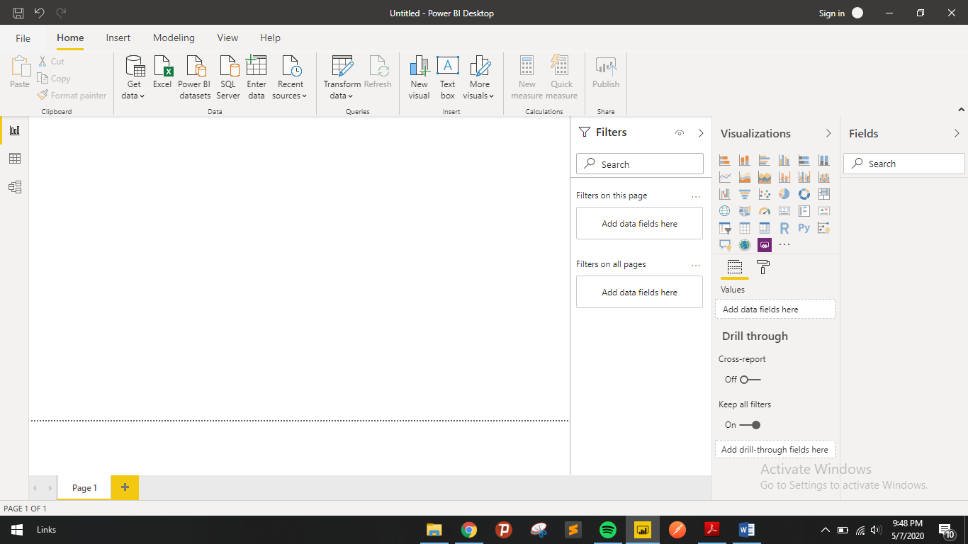

* **Prepare a document and with the following screenshot;**

1. **Report View:**

When we first load data in Power BI Desktop, you'll see the Report view with a blank canvas.

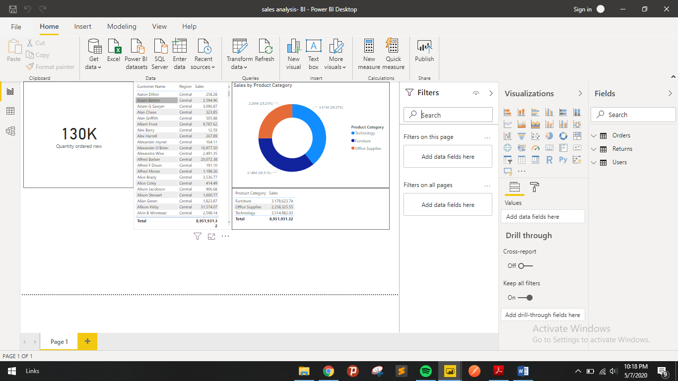

1. **Data View:**

Data view helps you inspect, explore, and understand data in your Power BI Desktop.

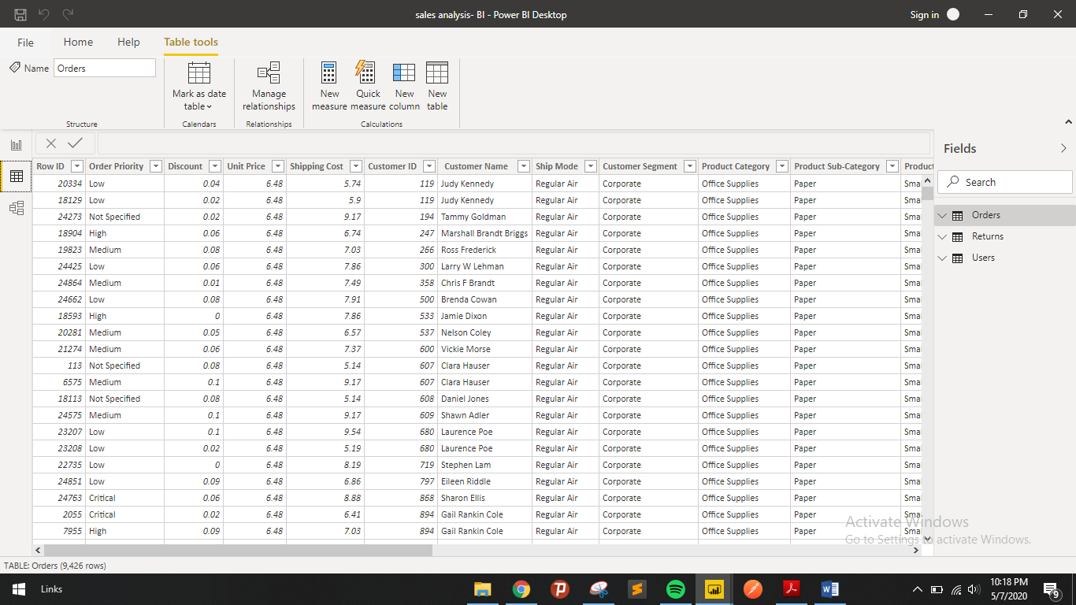

1. **Model View:**

Select the Model icon near the side of the window to see a view of the existing model. Hover your cursor over a relationship line to show the columns that are used.

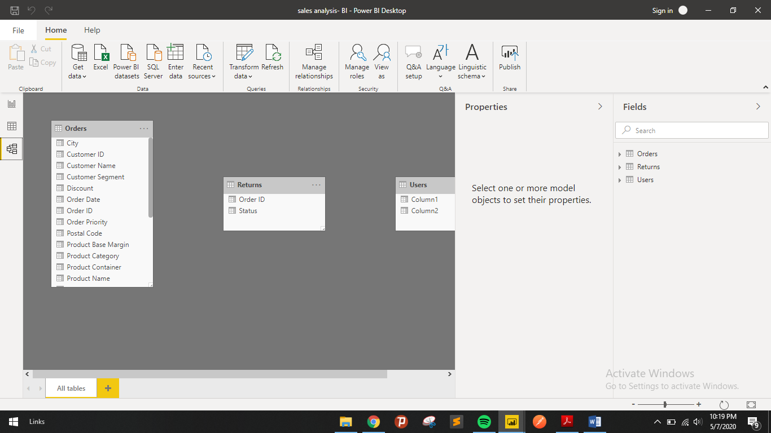

1. **Power Query Editor:**

The **Power Query Editor** is the primary data preparation experience, allowing users to apply over 300 different data transformations by previewing data and selecting transformations in the user experience. These data transformation capabilities are common across all data sources, regardless of the underlying data source limitations.

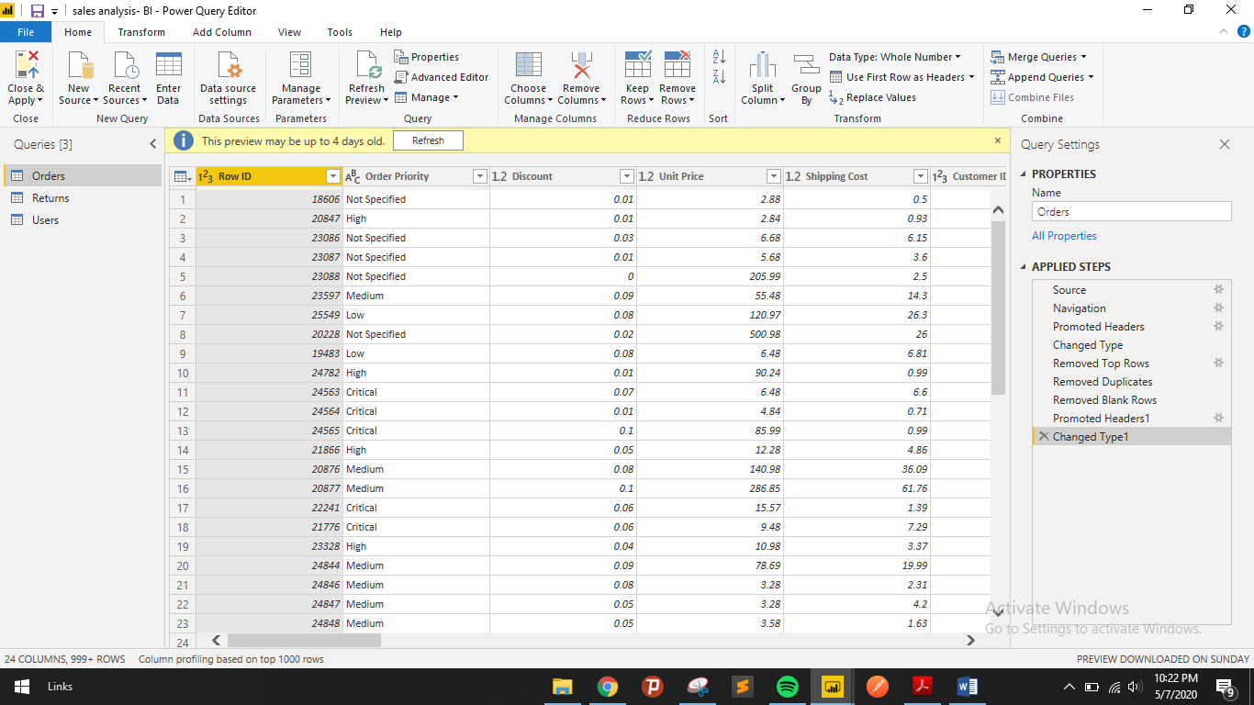

1. **Advance Editor:**

In Power BI, when we add data using Get Data button by connecting to the services, Power BI generates a query in background and we can modify this query and its data sources using 'Advanced Editor' Button.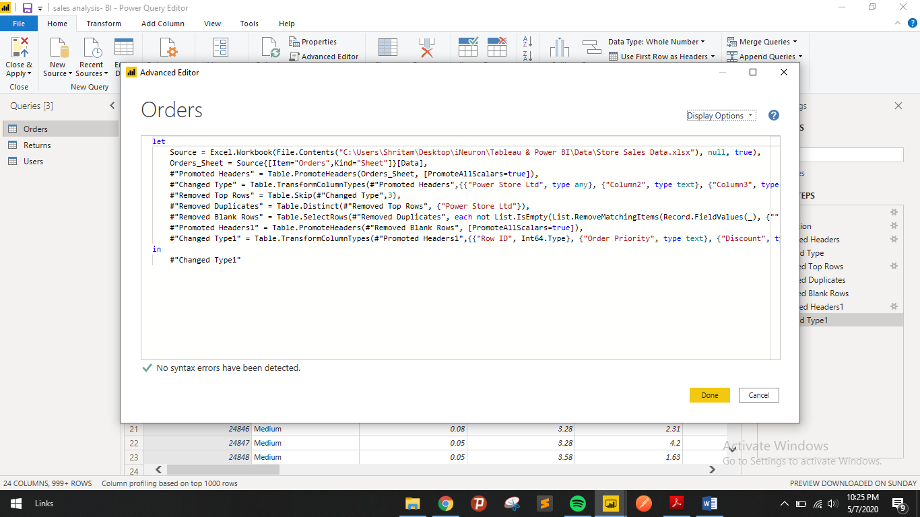

* **Prepare a document with details of the following along with their price.**

1. Power BI Desktop 🡪 Free
2. Power BI Pro 🡪 $9.99 Monthly price per user
3. Power BI Premium 🡪 $4,995 Monthly price per dedicated cloud compute and storage resource with annual subscription